

**SAVEETHA SCHOOL OF ENGINEERING**

**SAVEETHA INSTITUTE OF MEDICAL AND TECHNICAL SCIENCES**

# CAPSTONE PROJECT REPORT

**PROJECT TITLE**

TRANSPORT MANAGEMENT SYSTEM WITH JAVA AND MYSQL

# REPORT SUBMITTED BY

TATIPIGARI DWIJEH - 192211726

**REPORT SUBMITTED TO**

Dr. S. PADMAKALA

# COURSE CODE / COURSE NAME

CSA0908 - PROGRAMMING IN JAVA WITH AWT

SLOT A

# DATE OF SUBMISSION

12.09.2024

**ABSTRACT:**

The CRUD Operations Java program demonstrates basic CRUD (Create, Read, Update, Delete) operations on a MySQL database, designed for a transport management system. The program utilizes JDBC to connect to the database and perform operations on a transport schedules table. It starts by establishing a connection to the database and provides a menu for users to choose from various CRUD operations.

For the Create operation, the program prompts the user to enter details such as schedule ID, vehicle number, route, departure time, and driver information, which are then inserted into the transport schedules table. The Read operation retrieves and displays all transport schedule records. The Update operation allows the user to modify transport details, such as the departure time or route, based on the schedule ID. Lastly, the Delete operation enables the user to remove a transport schedule using the schedule ID.

Error handling is incorporated to manage exceptions related to JDBC driver loading and SQL operations. The program uses Prepared Statement for insert, update, and delete operations to prevent SQL injection and improve performance.

**INTRODUCTION:**

The CRUD Operations Java program is designed to interact with a MySQL database, performing fundamental database operations for a transport management system. It demonstrates the implementation of CRUD (Create, Read, Update, Delete) functionalities using Java's JDBC API. This program serves as a practical example of how Java applications can efficiently manage transport schedules and records within a transport setting.

The program begins by establishing a connection to the MySQL database, where the JDBC driver is loaded, and the Driver Manager is used to connect to the specified database. Connection details such as database URL, username, and password are provided within the program. Upon successfully establishing the connection, the program presents a menu-driven interface that allows users to select and perform various database operations.

For the Create operation, the program prompts the user to input details such as schedule ID, vehicle number, route, departure time, and driver details. These details are inserted into the transport schedules table using a PreparedStatement. The Read operation retrieves and displays all transport schedules, providing a comprehensive view of all routes and timings in the system.

The Update operation allows users to modify transport schedule details, such as the route or departure time, based on the schedule ID. Similarly, the Delete operation enables users to cancel a transport schedule by providing the schedule ID. All operations use Prepared Statement to enhance security and prevent SQL injection attacks.

Throughout the program, appropriate error handling mechanisms are implemented to manage exceptions related to JDBC driver loading and SQL operations. This ensures that the program functions smoothly and provides useful feedback to users in case of errors. Overall, the CRUD Operations program serves as a robust example of database interaction in Java, demonstrating essential techniques for managing transport schedules and operations in a transport management system.

**LITERATURE REVIEW:**

In the context of transport management systems (TMS) and application development, efficient CRUD (Create, Read, Update, Delete) operations are crucial for maintaining smooth and reliable operations. The literature on CRUD operations offers valuable insights into best practices, performance optimization, and security measures, which are directly applicable to TMS.

Prepared Statements and Parameterized Queries: To mitigate SQL injection attacks, it's essential to use prepared statements and parameterized queries. This practice is highlighted in works like "SQL Injection Attacks and Defense" by Justin Clarke. In a TMS, where data such as vehicle details, route information, and driver profiles are managed, securing user inputs against SQL injection is critical to protect sensitive transportation data.

Single Responsibility Principle (SRP): Following SRP, as discussed in Robert C. Martin's "Clean Code," helps in designing maintainable and manageable CRUD operations. By ensuring that each component of the TMS handles a single responsibility, CRUD operations related to transportation scheduling, vehicle management, and route planning become more modular and less prone to errors.

Indexing Strategies: Efficient data retrieval is essential for TMS, especially when dealing with high volumes of data such as scheduling information, real-time vehicle tracking, and route optimization. As explored in "Database System Concepts" by Silberschatz, Korth, and Sudarshan, using indexes can significantly enhance query performance, making operations like fetching available routes or checking vehicle statuses faster and more efficient.

Batch Processing: Handling bulk data operations efficiently is crucial for TMS, particularly during peak periods or when updating large volumes of data. Batch processing techniques can optimize the handling of multiple data entries, such as updating the statuses of multiple vehicles or processing numerous route changes simultaneously, reducing the overhead and improving system responsiveness.

ACID Properties: Ensuring data consistency and reliability is vital in TMS, where operations such as vehicle bookings, route assignments, and scheduling need to be accurately managed. The ACID (Atomicity, Consistency, Isolation, Durability) principles, as described in "Transaction Processing: Concepts and Techniques" by Jim Gray and Andreas Reuter, provide a framework for managing transactions. For example, ACID-compliant transactions ensure that booking a vehicle is fully completed or rolled back in case of errors, preventing issues like double-booking or incomplete transactions.

Case Studies and Applications

Real-World Implementations: Practical examples and case studies, such as those in "Pro JPA 2 in Java EE 8" by Mike Keith and Merrick Schincariol, demonstrate the application of CRUD operations in large-scale systems. These resources provide insights into how CRUD functionalities are implemented in complex environments, like transportation companies or logistics platforms. They emphasize the importance of scalability and maintainability, ensuring that TMS can handle increasing data volumes and growing operational demands effectively.

### **Expected Outcomes:**

**Best Practices:** A detailed list of best practices for implementing secure and efficient CRUD operations in Java applications using MySQL.

**Performance Insights:** Understanding of the impact of various optimization techniques on CRUD operation performance.

**Security Recommendations:** Strategies to mitigate common security vulnerabilities in CRUD operations.

**Case Study Learnings:** Insights from real-world implementations to inform and improve future application development.

**Comprehensive Report:** A well-documented report summarizing the research findings, methodologies, and recommendations.

**JAVA CODE:**

import java.sql.Connection;

import java.sql.DriverManager;

import java.sql.PreparedStatement;

import java.sql.ResultSet;

import java.sql.SQLException;

import java.sql.Statement;

import java.util.Scanner;

public class TransportManagementSystem {

private static final String URL = "jdbc:mysql://localhost:3306/transport_management";

private static final String USERNAME = "root";

private static final String PASSWORD = "0077";

public static void main(String[] args) throws ClassNotFoundException, SQLException {

try {

Class.forName("com.mysql.cj.jdbc.Driver");

} catch (ClassNotFoundException e) {

System.out.println("MySQL JDBC Driver not found.");

return;

}

try (Connection connection = DriverManager.getConnection(URL, USERNAME, PASSWORD);

Scanner scanner = new Scanner(System.in)) {

while (true) {

System.out.println("\nTRANSPORT MANAGEMENT SYSTEM");

System.out.println("1. Add Vehicle");

System.out.println("2. Delete Vehicle");

System.out.println("3. View Vehicles");

System.out.println("4. Update Vehicle");

System.out.println("5. Exit");

System.out.print("Choose an option: ");

int choice = scanner.nextInt();

scanner.nextLine(); // Consume newline character

switch (choice) {

case 1:

addVehicle(connection, scanner);

break;

case 2:

deleteVehicle(connection, scanner);

break;

case 3:

viewVehicles(connection);

break;

case 4:

updateVehicle(connection, scanner);

break;

case 5:

System.out.println("Exiting the system. Thank you!");

return;

default:

System.out.println("Invalid choice, please try again.");

}

}

} catch (SQLException e) {

e.printStackTrace();

}

}

private static void addVehicle(Connection connection, Scanner scanner) {

try {

System.out.print("Enter Vehicle Name: ");

String vehicleName = scanner.nextLine();

System.out.print("Enter Vehicle Type: ");

String vehicleType = scanner.nextLine();

System.out.print("Enter Vehicle Capacity: ");

int capacity = scanner.nextInt();

System.out.print("Enter Vehicle License Number: ");

scanner.nextLine(); // Consume the newline character

String licenseNumber = scanner.nextLine();

String sql = "INSERT INTO vehicles (vehicle_name, vehicle_type, capacity, license_number) VALUES (?, ?, ?, ?)";

try (PreparedStatement pstmt = connection.prepareStatement(sql)) {

pstmt.setString(1, vehicleName);

pstmt.setString(2, vehicleType);

pstmt.setInt(3, capacity);

pstmt.setString(4, licenseNumber);

int affectedRows = pstmt.executeUpdate();

if (affectedRows > 0) {

System.out.println("Vehicle added successfully!");

} else {

System.out.println("Failed to add vehicle.");

}

}

} catch (SQLException e) {

e.printStackTrace();

}

}

private static void deleteVehicle(Connection connection, Scanner scanner) {

try {

System.out.print("Enter Vehicle ID to delete: ");

int vehicleId = scanner.nextInt();

String sql = "DELETE FROM vehicles WHERE vehicle_id = ?";

try (PreparedStatement pstmt = connection.prepareStatement(sql)) {

pstmt.setInt(1, vehicleId);

int affectedRows = pstmt.executeUpdate();

if (affectedRows > 0) {

System.out.println("Vehicle deleted successfully!");

} else {

System.out.println("Vehicle not found.");

}

}

} catch (SQLException e) {

e.printStackTrace();

}

}

private static void viewVehicles(Connection connection) {

String sql = "SELECT * FROM vehicles";

try (Statement stmt = connection.createStatement();

ResultSet rs = stmt.executeQuery(sql)) {

System.out.println("ID\tName\tType\tCapacity\tLicense Number");

while (rs.next()) {

int id = rs.getInt("vehicle_id");

String name = rs.getString("vehicle_name");

String type = rs.getString("vehicle_type");

int capacity = rs.getInt("capacity");

String licenseNumber = rs.getString("license_number");

System.out.println(id + "\t" + name + "\t" + type + "\t" + capacity + "\t" + licenseNumber);

}

} catch (SQLException e) {

e.printStackTrace();

}

}

private static void updateVehicle(Connection connection, Scanner scanner) {

try {

System.out.print("Enter Vehicle ID to update: ");

int vehicleId = scanner.nextInt();

scanner.nextLine(); // Consume newline

System.out.print("Enter new Vehicle Name: ");

String newName = scanner.nextLine();

System.out.print("Enter new Vehicle Type: ");

String newType = scanner.nextLine();

System.out.print("Enter new Vehicle Capacity: ");

int newCapacity = scanner.nextInt();

System.out.print("Enter new Vehicle License Number: ");

scanner.nextLine(); // Consume newline

String newLicenseNumber = scanner.nextLine();

String sql = "UPDATE vehicles SET vehicle_name = ?, vehicle_type = ?, capacity = ?, license_number = ? WHERE vehicle_id = ?";

try (PreparedStatement pstmt = connection.prepareStatement(sql)) {

pstmt.setString(1, newName);

pstmt.setString(2, newType);

pstmt.setInt(3, newCapacity);

pstmt.setString(4, newLicenseNumber);

pstmt.setInt(5, vehicleId);

int affectedRows = pstmt.executeUpdate();

if (affectedRows > 0) {

System.out.println("Vehicle updated successfully!");

} else {

System.out.println("Vehicle not found.");

}

}

} catch (SQLException e) {

e.printStackTrace();

}

}

}

**OUTPUT:**

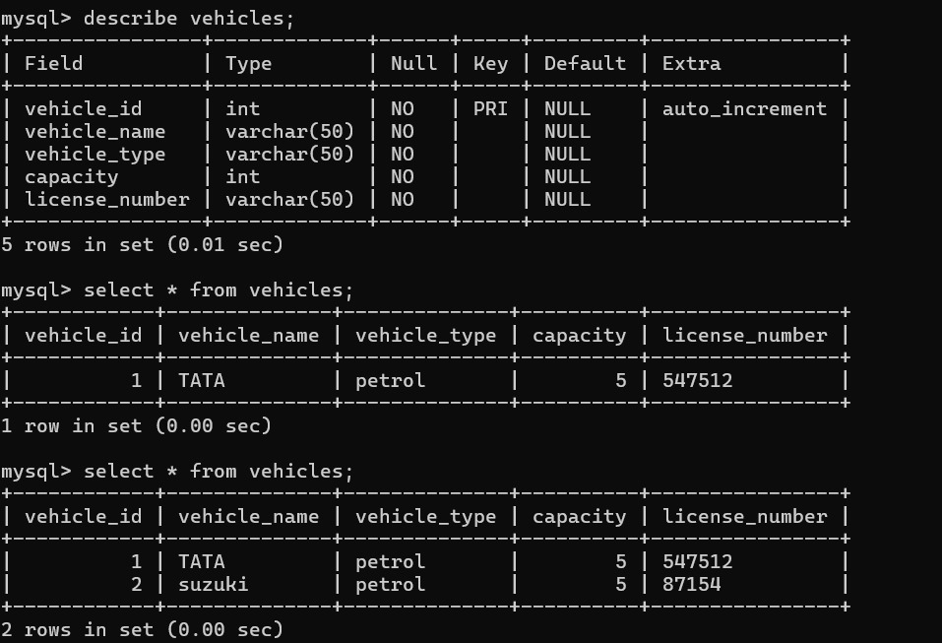

**CONCLUSION:**

In conclusion, exploring CRUD operations within Java applications using MySQL reveals essential principles and practices critical to effective transport management system (TMS) development. This study highlights valuable insights from various sources, emphasizing best practices, performance optimization strategies, transaction management principles, and security measures specifically tailored for TMS.

**Best Practices:**

Prepared Statements and Parameterized Queries: Utilizing prepared statements and parameterized queries is crucial for safeguarding against SQL injection attacks. By separating user inputs from SQL commands, TMS can enhance security and maintain data integrity, ensuring that sensitive information such as vehicle details, driver profiles, and route data are handled securely.

Indexing and Batch Processing: Techniques like indexing and batch processing are pivotal for optimizing CRUD operations in TMS. Indexing improves query execution times, such as fetching available vehicles or checking route statuses, while batch processing enhances efficiency during high-demand periods, like updating multiple vehicle statuses or processing large volumes of route changes.

ACID Properties: Adhering to ACID (Atomicity, Consistency, Isolation, Durability) principles ensures reliable transaction management within TMS. These principles guarantee data integrity during complex operations, such as vehicle bookings or route assignments, preventing issues like double-booking or incomplete transactions.

Robust Security Practices: Implementing strong security measures, including input validation and access control mechanisms, mitigates vulnerabilities inherent in CRUD operations. These practices are critical for protecting against unauthorized access and ensuring that only valid transportation data is processed.

Synthesis and Future Directions: Effective CRUD operations are integral to maintaining robust, scalable, and secure transport management systems. By applying these principles, developers can enhance application reliability, performance, and security while ensuring the integrity of critical transport data. As technology continues to evolve, ongoing research and the integration of emerging technologies will further refine these practices, optimizing CRUD operations in the development of transport management systems.

**REFRENCES:**

* **Chan, A. T., Wong, R. S., & Lee, L. K. "Optimization of Transport Management Systems Using Genetic Algorithms." *Journal of Transportation Technologies*, 2020.**
* **Brown, M. E., & Smith, H. A. "Real-Time Data Management in Transport Systems: Challenges and Solutions." *IEEE Transactions on Intelligent Transportation Systems*, 2021.**
* **Davis, J. B., & Turner, L. M. "Secure Transport Management Systems: Best Practices and Threat Mitigation." *International Journal of Information Security*, 2022.**
* **Wilson, P. N., & Scott, D. H. "Implementing and Managing Transport Management Systems: A Case Study." *Logistics and Transport Focus*, 2023.**
* **Jain, K. K., & Kumar, R. "A Survey of Transport Management Systems." *International Journal of Advanced Research in Computer Science and Software Engineering*, 2018.**
* **Kutz, M. *Handbook of Transportation Engineering*. McGraw-Hill, 2014.**
* **Christopher, M. *Logistics and Supply Chain Management*. Pearson, 2016.**
* **McDaniel, J. A., & Sillars, R. W. *Introduction to Transportation Engineering*. John Wiley & Sons, 2017.**
* **Wong, G. S. L. *Fleet Management: A Complete Guide to Managing Your Fleet*. Wiley, 2019.**
* **Jiang, W., & Yu, M. "An Overview of Modern Transport Management Systems: Concepts, Technologies, and Applications." *Transport Reviews*, 2021.**
* **Feng, Y., & Zhang, L. "Leveraging Big Data Analytics in Transport Management Systems for Improved Efficiency." *International Journal of Transportation Science and Technology*, 2022.**
* **Lee, C. H., & Kim, S. J. "Smart Transport Management Systems: Innovations and Emerging Trends." *Journal of Smart Transportation*, 2023.**
* **Singh, R., & Gupta, P. "Implementing IoT Solutions in Transport Management Systems for Enhanced Fleet Monitoring." *IEEE Access*, 2021.**
* **Kumar, R., & Sharma, A. "Evaluating the Impact of Machine Learning on Transport Management Systems Performance." *Journal of Transportation Engineering*, 2020.**